**Voyage Vista: Illuminating Insights From Uber Expeditionary Analysis**

1.Introduction:

1.1. Overview:

Uber is a multinational transportation network company that operates a ride-hailing platform. It was founded in 2009 by Garrett Camp and Travis Kalanick and is based in San Francisco, California. Uber provides a convenient way for individuals to request rides from drivers who use their own personal vehicles.

Uber Driver Analysis refers to the Analyzing the number of trips taken by Uber drivers can provide insights into their overall activity and the demand for rides in specific areas. Daily, Weekly, or Monthly Analysis: Uber's data can be analyzed on a daily, weekly, monthly basis to understand the trends and patterns of trip volumes.

1.2. Purpose:

This analysis can help identify peak hours or days of high demand and optimize driver availability during those times. Trips can be analyzed based on geographic regions or specific cities to identify areas with higher demand. This analysis can help Uber drivers decide where to focus their driving efforts for maximum efficiency and profitability. The Major of our project is to use data Analyzing techniques to find unknown patterns in the Uber Drives dataset. The research is carried out on Uber drives data collected from the year 2016.

2.Problem statement & Design Thinking:

The objective of this Uber analysis using Tableau is to gain insights and explore various aspects of Uber's operations and user behavior. By leveraging the data visualization capabilities of Tableau, we aim to create interactive and visually appealing dashboards that provide a comprehensive view of Uber's performance, trends, and opportunities for improvement.

2.1. Empathy Map: 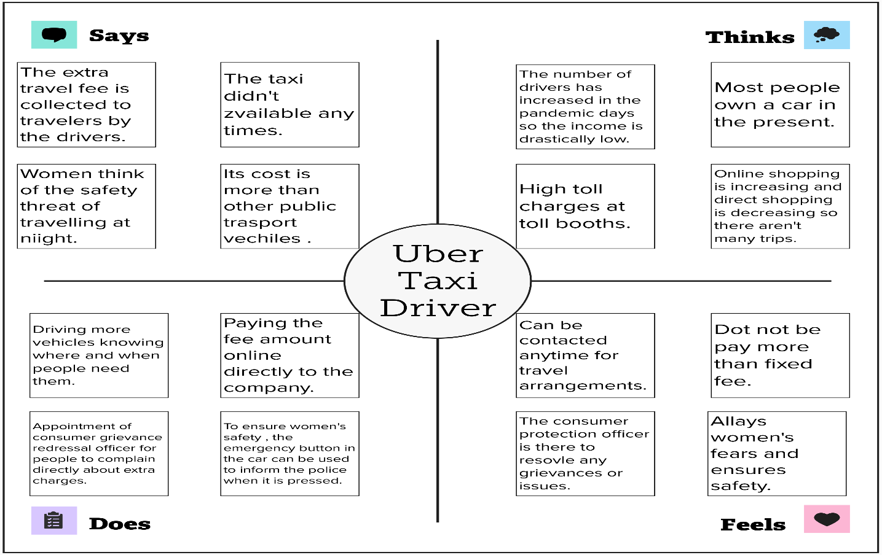

2.2. Ideation and Brainstorming Map:

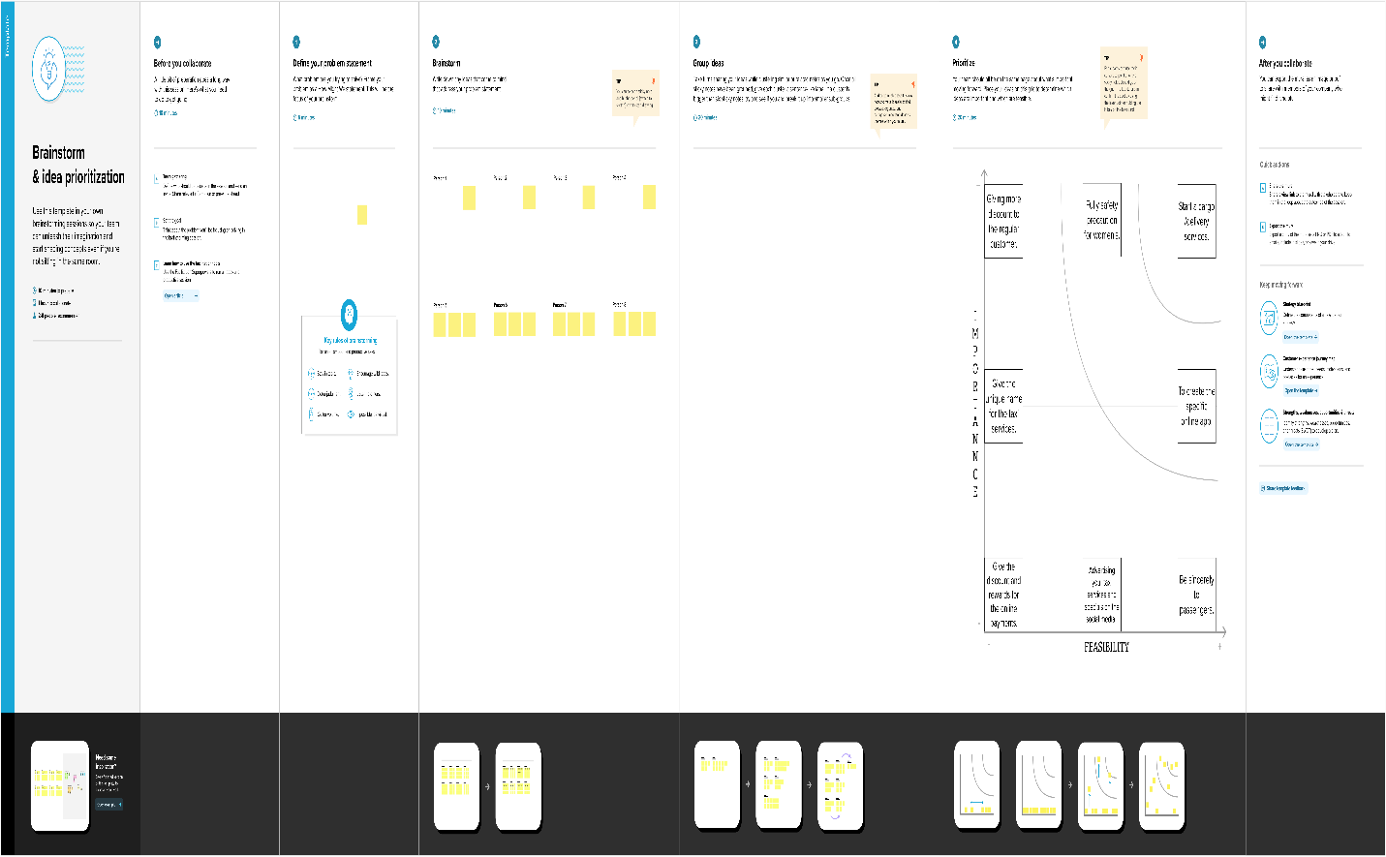

3.Result:

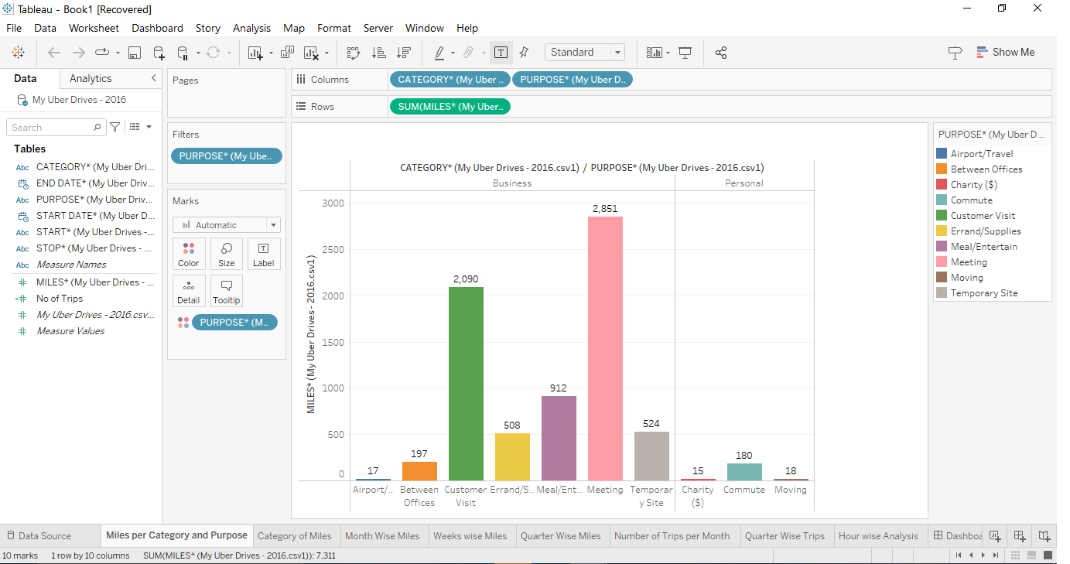

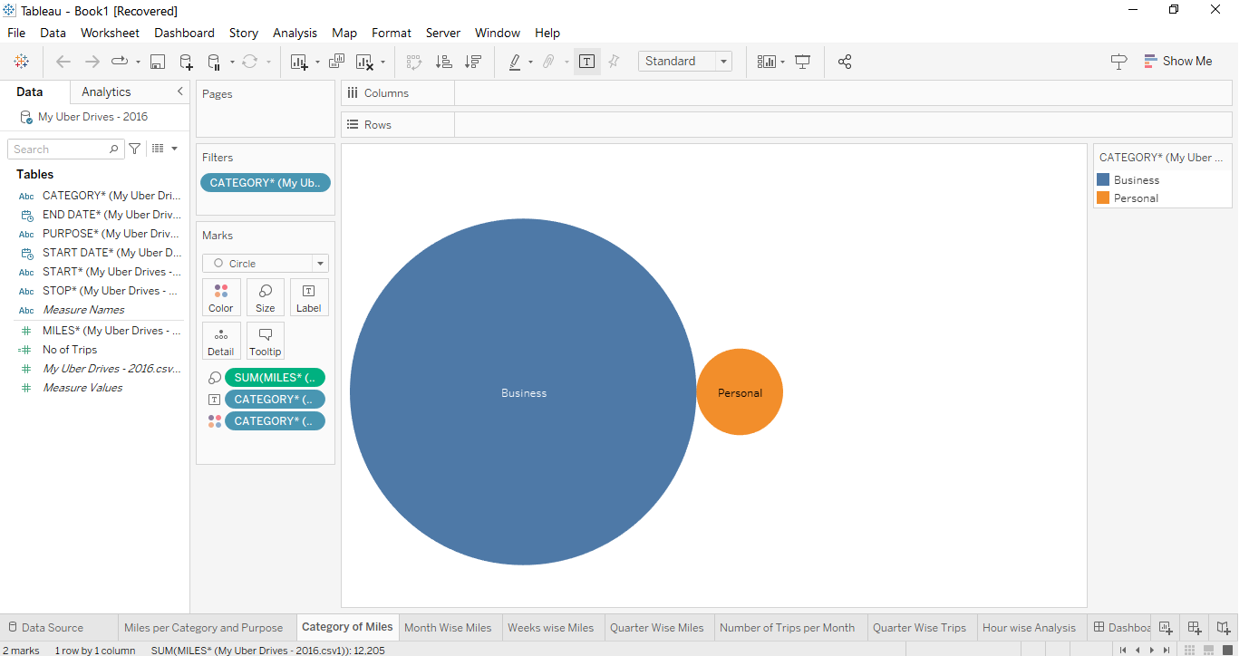

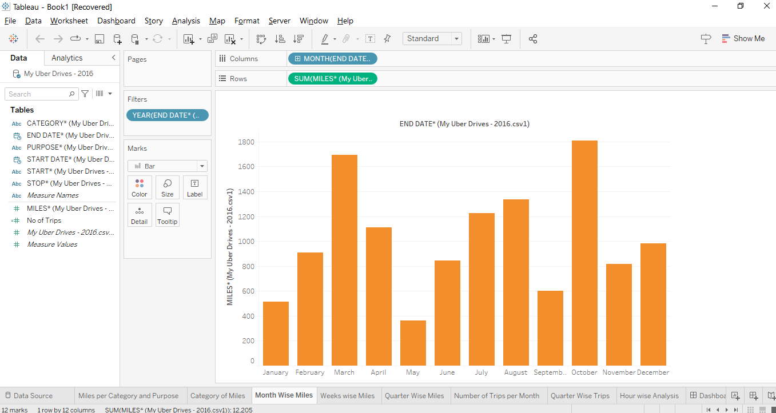

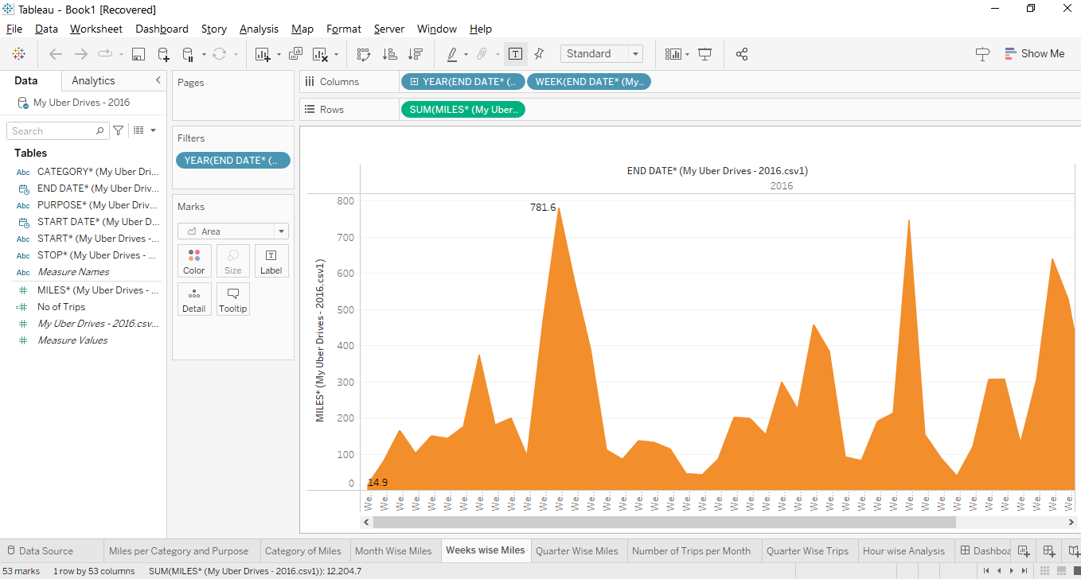

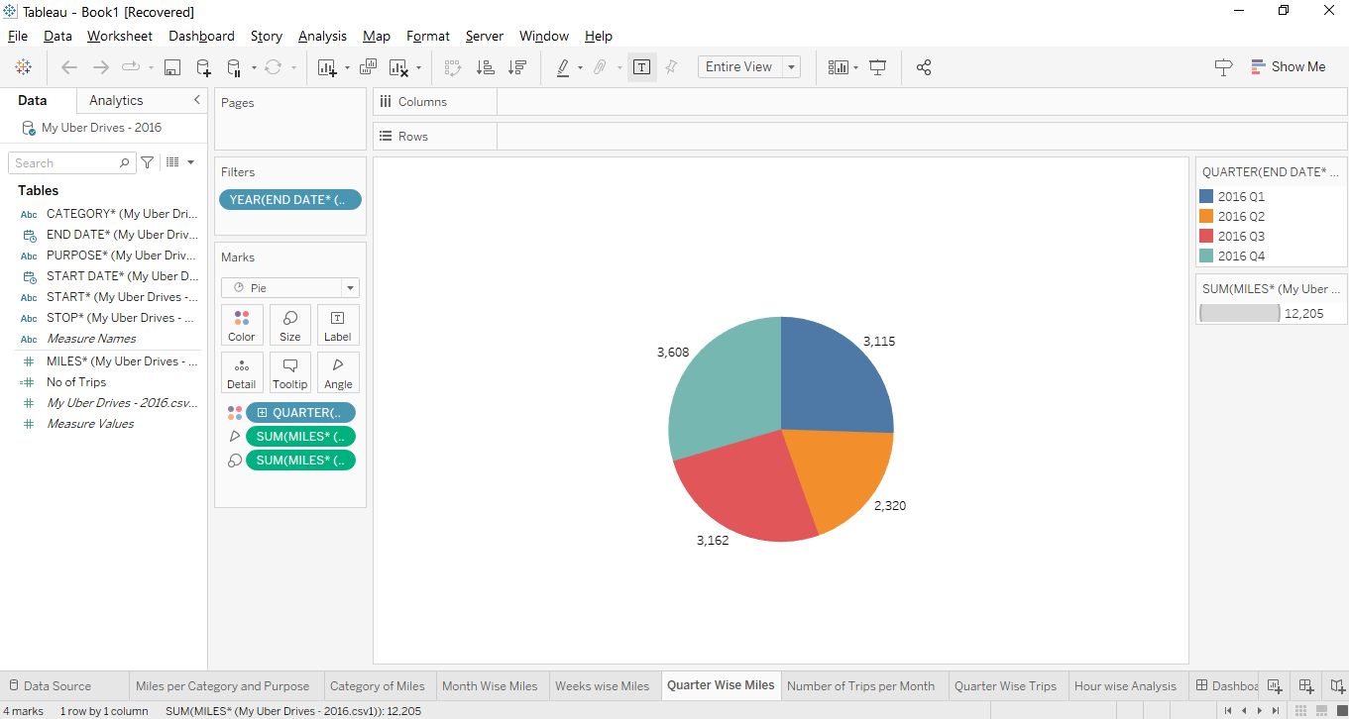

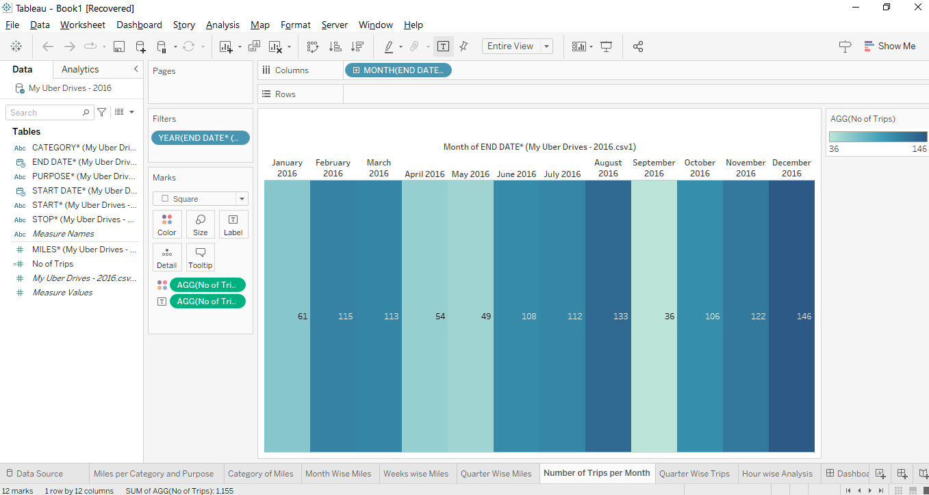

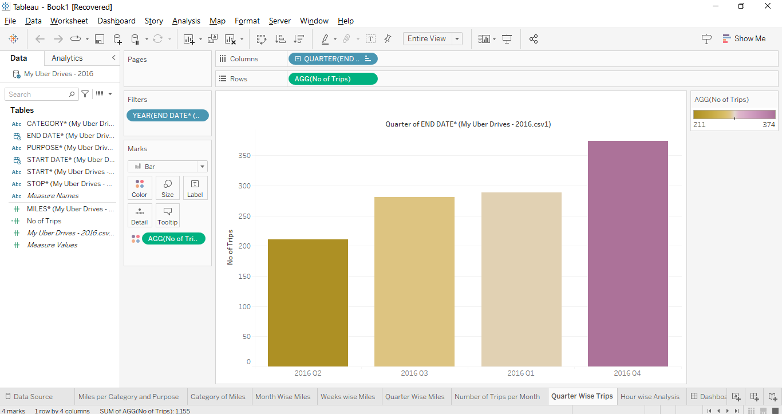

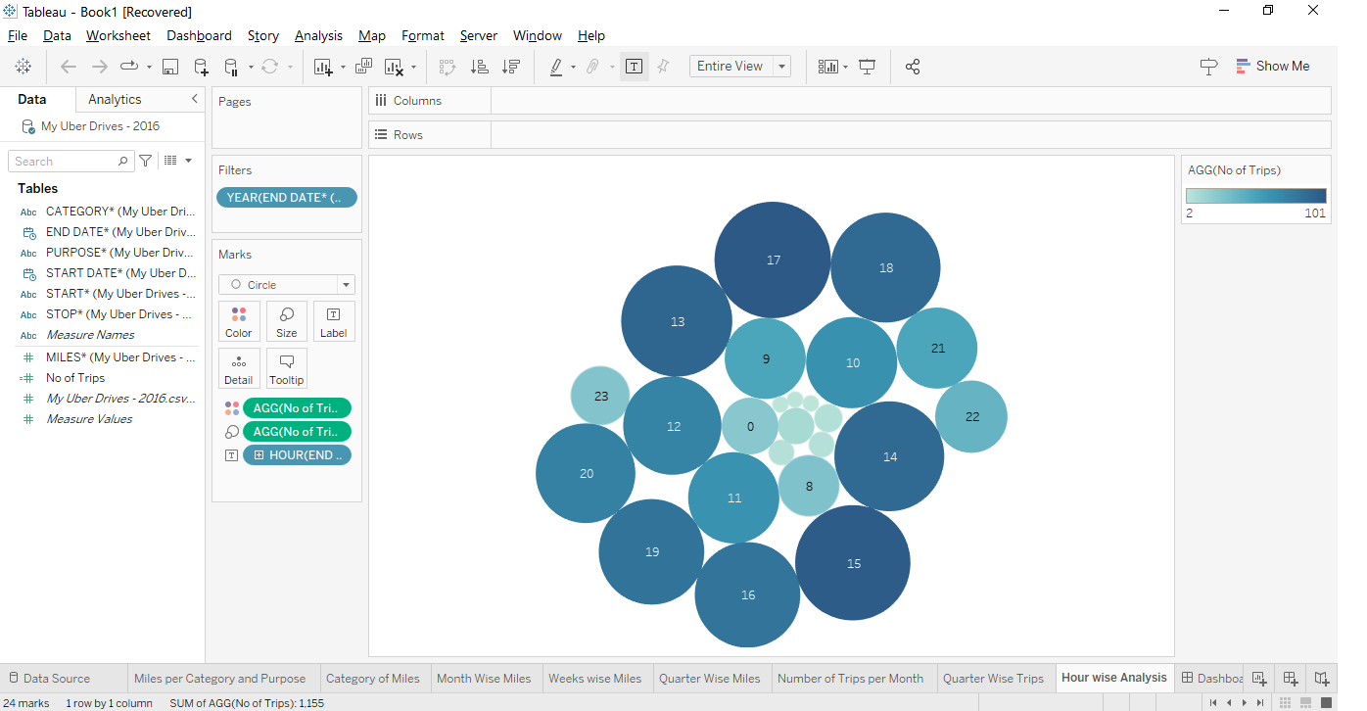

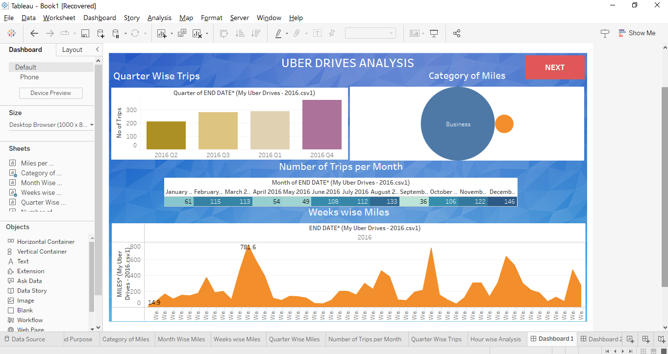

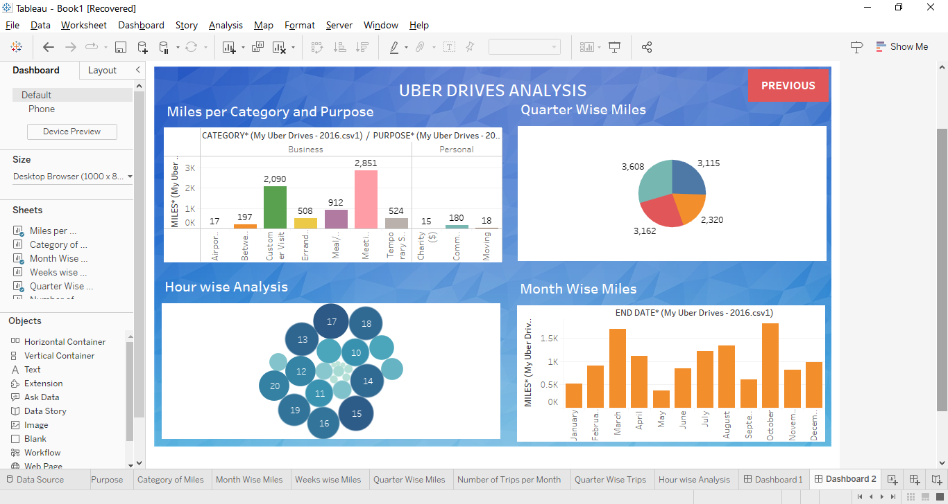

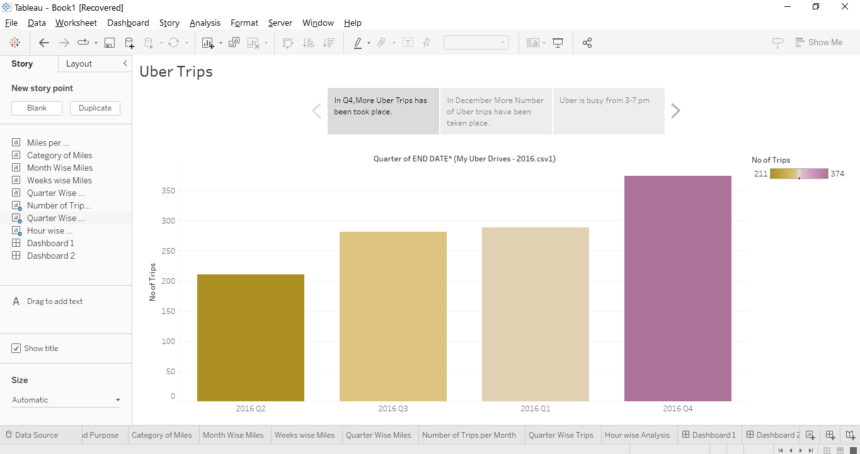

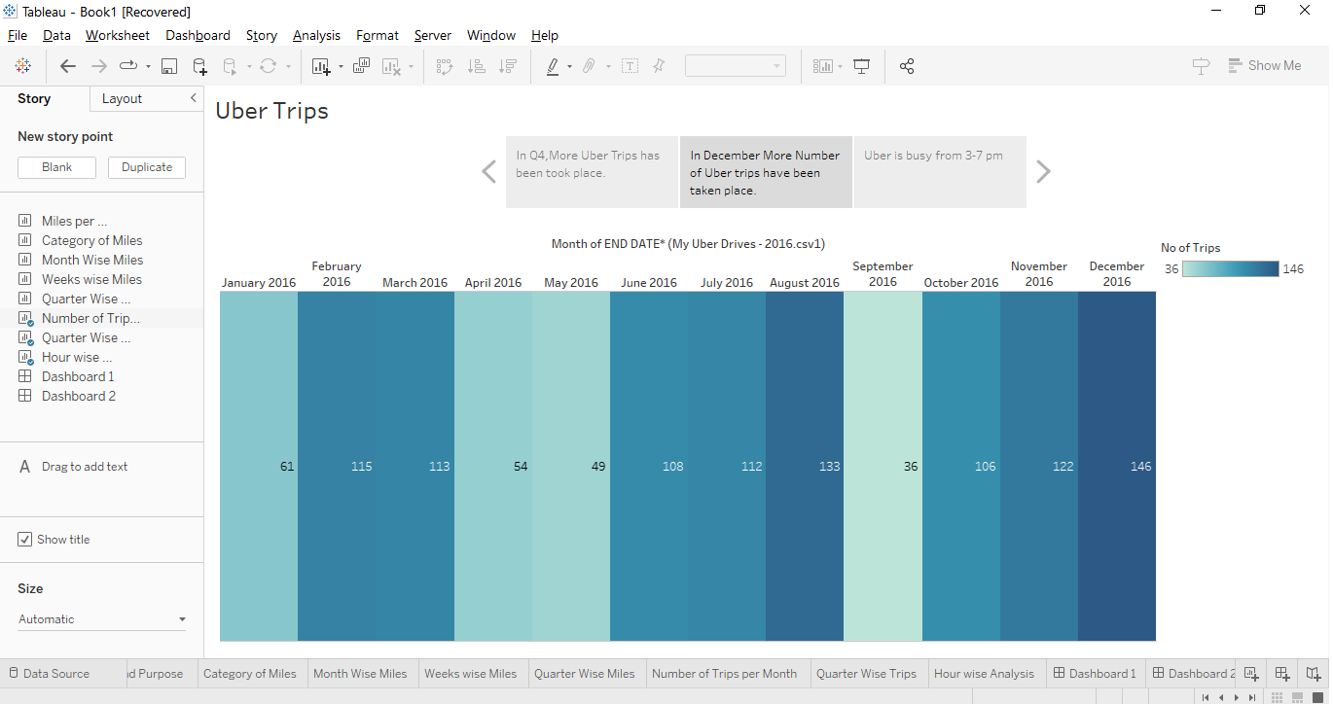

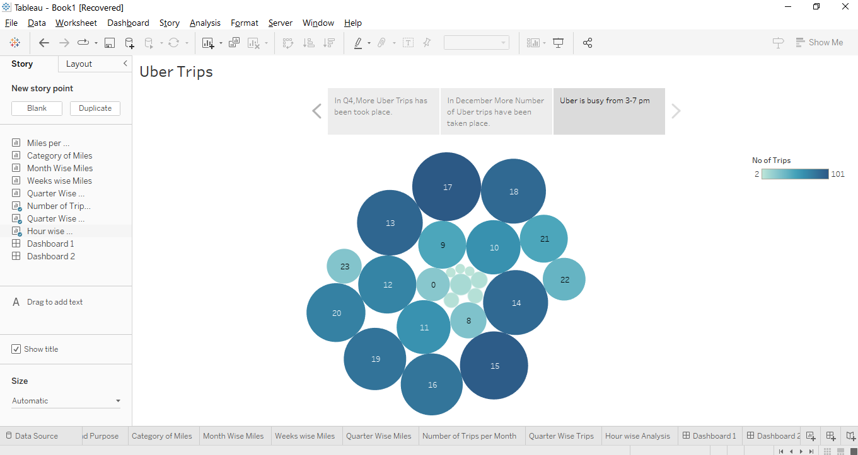

4. Advantages and Disadvantages:

The advantages are,

* We are calculating the trips taken in the hour wise, week wise, month wise and quarter wise.
* We are calculating which month uber taking a greater number of trips.
* We are calculating which time peoples are want to and trip the uber services.

The disadvantages are,

* Uber didn’t give more services in peak hours.
* Uber didn’t full feel the required demands.
* Uber cannot increase the availability.

5. Applications:

This analysis can help identify peak hours or days of high demand and optimize driver availability during those times. Trips can be analyzed based on geographic regions or specific cities to identify areas with higher demand.

6. Conclusion:

Finally, we are concluded that this project is

1. In Q4, More Uber Trips has been took place.
2. In December More Number of Uber trips have been taken place.
3. Uber is busy from 3-7 pm.

7. Future Scope:

* We can use this data for training a model using ML and building a smart AI based predictive system.
* Model can automatically send the insights to the authorities or drivers related to areas having most trips and passenger count in certain areas.
* This big data can be used to study passenger’s  
  behavior.